# CS315A - Project

# Idea – Restaurant Slot Booking (BARATIE)

Our idea is to build an application for customers where they can reserve a table at restaurant at a preferred time and date and pre-order dishes present in the restaurant based on their wish and rating.

# Website Design

* New User has to register, existing users can login with their credentials.
* Once they login they will be given choices of slots available in our database.
* Now if they wish, they can pre-order their choice of dishes that they want to have.
* Then they can click “Reserve Now” to confirm their booking and they will be presented with estimated bill.

# Technical Details

* Front-End: Used PHP, CSS, JS.
* 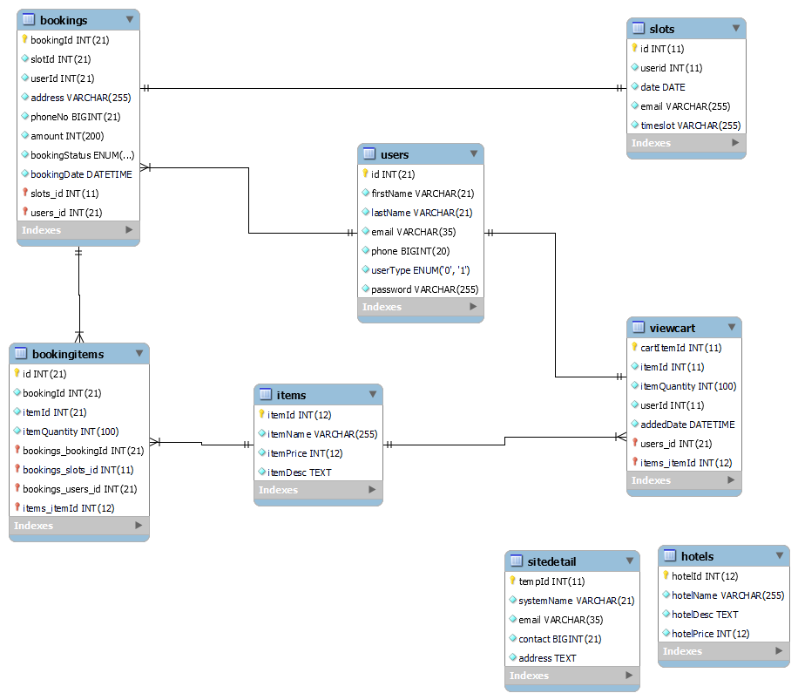Back-end: Used MySQL.

Tables that we used/created in this project.

1. Hotels - hotelId (primary key)

|  |  |  |  |
| --- | --- | --- | --- |
| **hotelId** | **hotelName** | **hotelDesc** | **hotelPrice** |
|  |  |  |  |
|  |  |  |  |
|  |  |  |  |

1. Booking items – Id(primary key)

|  |  |  |  |
| --- | --- | --- | --- |
| **Id** | **bookingId** | **itemId** | **itemQuantity** |
|  |  |  |  |
|  |  |  |  |

1. Bookings – bookingId(primary key)

|  |  |  |  |  |  |  |  |
| --- | --- | --- | --- | --- | --- | --- | --- |
| bookingid | slotId | userID | Address | phoneNo | Amount | BookingStatus | bookingDate |
|  |  |  |  |  |  |  |  |
|  |  |  |  |  |  |  |  |

1. Items – itemId(primay key)

|  |  |  |  |
| --- | --- | --- | --- |
| itemId | itemName | itemPrice | itemDesc |
|  |  |  |  |
|  |  |  |  |

1. Users – Id(primary key)

|  |  |  |  |  |  |  |
| --- | --- | --- | --- | --- | --- | --- |
| Id | firstName | lastName | Email | Phone | Usertype | password |
|  |  |  |  |  |  |  |
|  |  |  |  |  |  |  |

1. View cart – cartItemId(primary key)

|  |  |  |  |  |
| --- | --- | --- | --- | --- |
| cartItemId | itemId | itemQuantity | userId | addedDate |
|  |  |  |  |  |
|  |  |  |  |  |

1. Slots – Id(primary key)

|  |  |  |  |
| --- | --- | --- | --- |
| Id | userId | Date | email |
|  |  |  |  |
|  |  |  |  |

Contribution

|  |  |  |
| --- | --- | --- |
| Yeddula Vinay Chandu | 191181 | 50% |
| Kartavya | 180343 | 50% |